SHELL SCRIPTING DOCUMENTATION

1. Write a script five_dirs.sh that does these tasks:  
   a. make a directory five.  
   b. make five subdirectories five/dir1 through five/dir5.  
   c. in each subdirectory, make four files, file1 through file4, such that file1 has one line containing the digit 1, file2 has two lines, each containing the digit 2, ..., and file4 has four lines, each containing the digit 4

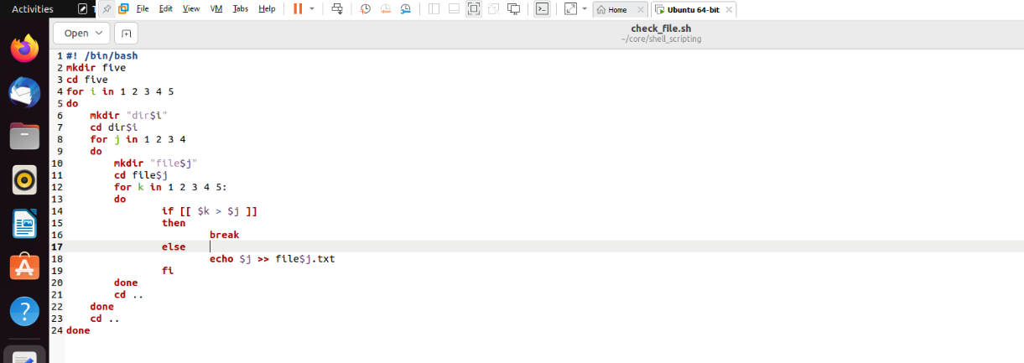

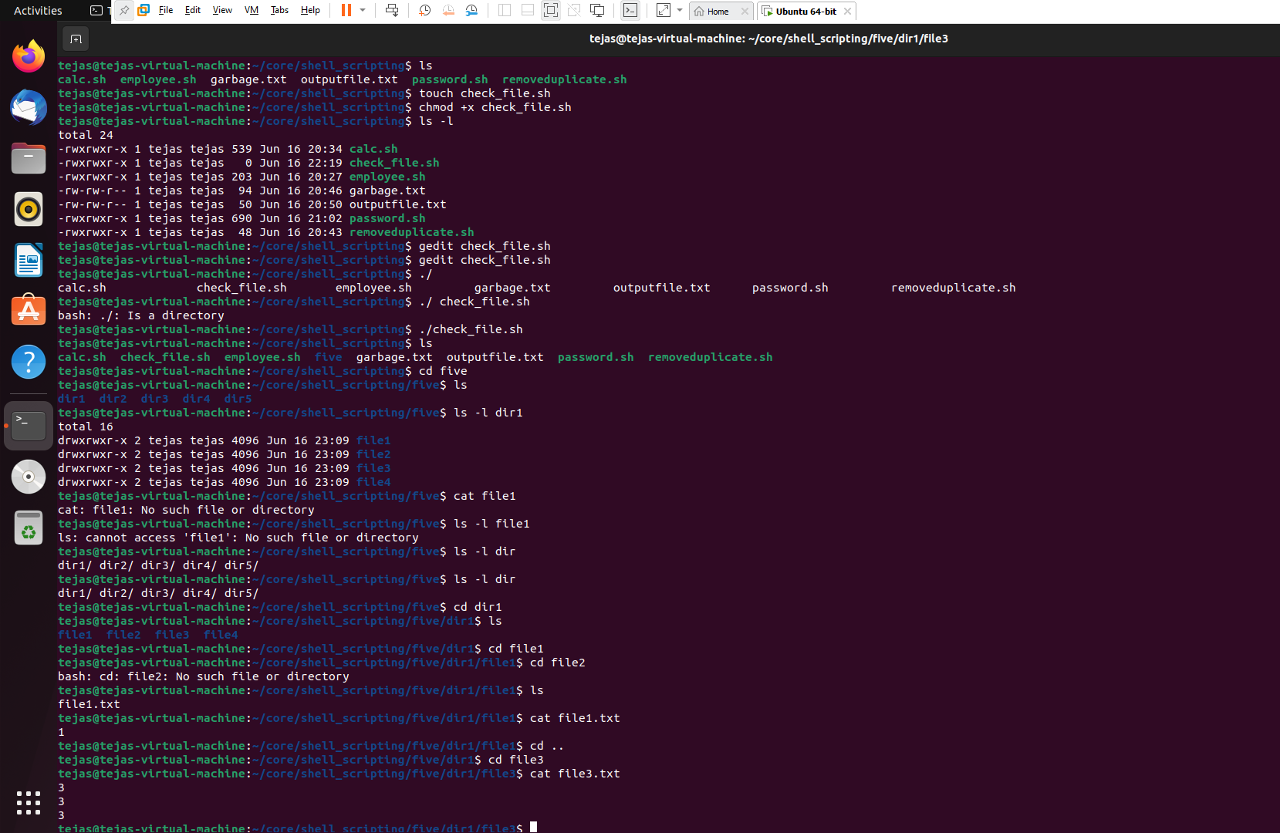

1. Get user input of file path and evaluate the status of a file ( Whether it is writable, executable/searchable, readable, directory etc).
2. Write a program to calculate overtime pay of employees. Overtime is paid at the rate of Rs. 12.00 per hour for every hour worked above 40 hours. Assume that employees do not work for fractional part of an hour.

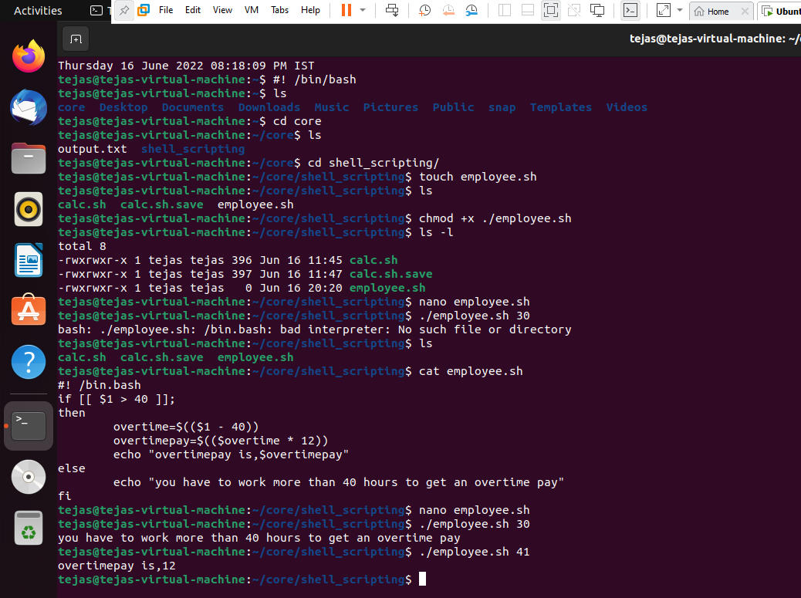

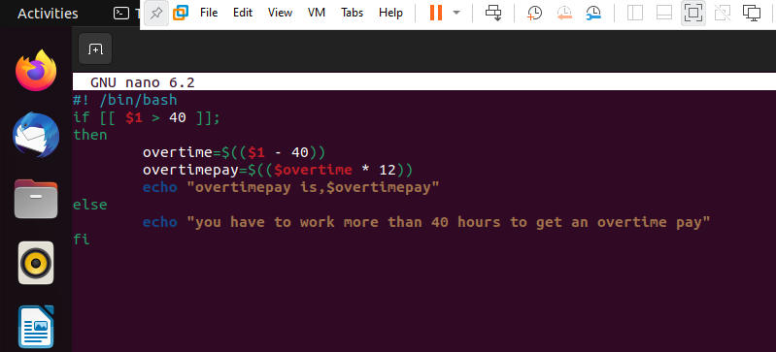

1. Write a script that every time, I reboot there should be an email sent to Admin that takes dump of last 100 message of dmesg in zipped form.
2. Write a shell script that will take an input file and remove identical lines (or duplicate lines from the file).

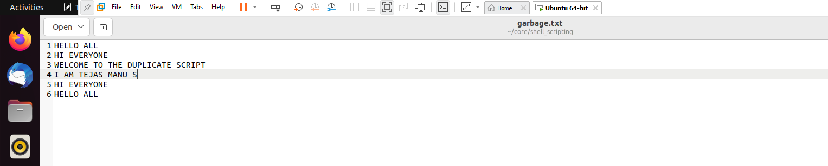

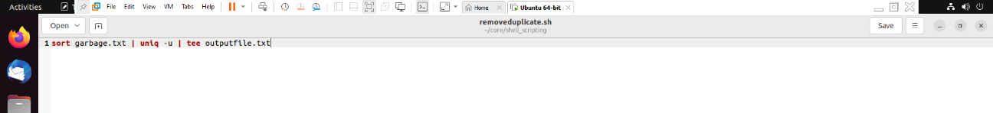

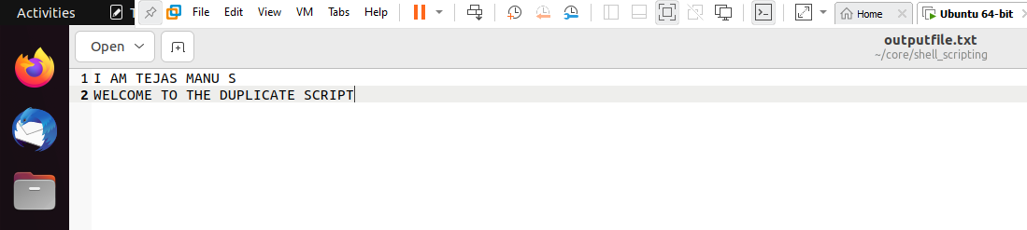

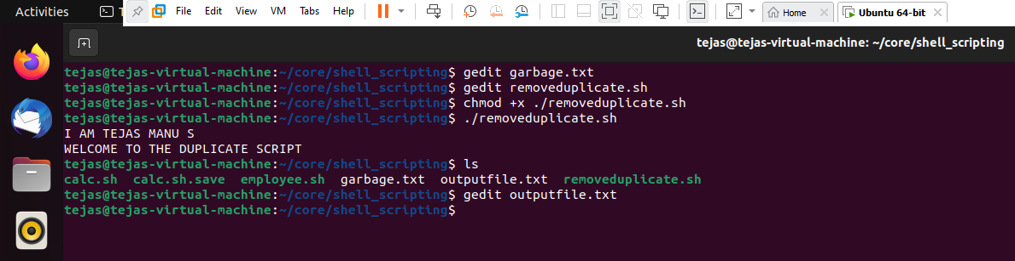

1. Create a bash file to assess password strength.   
   a. Minimum Characters should be 6.   
   b. Should Contain both alphabet and number.   
   c. Should Include both the small and capital case letters.   
   d. If the password doesn’t comply with any of the above conditions, then the script should report it as a <Weak Password>

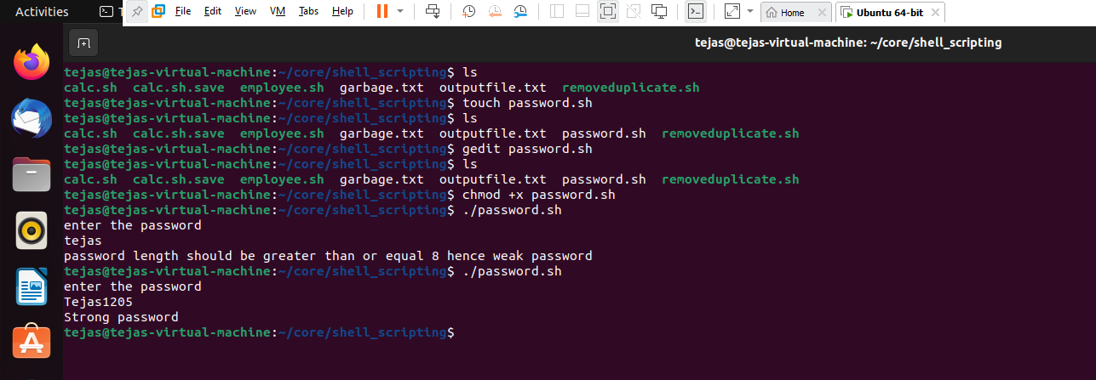

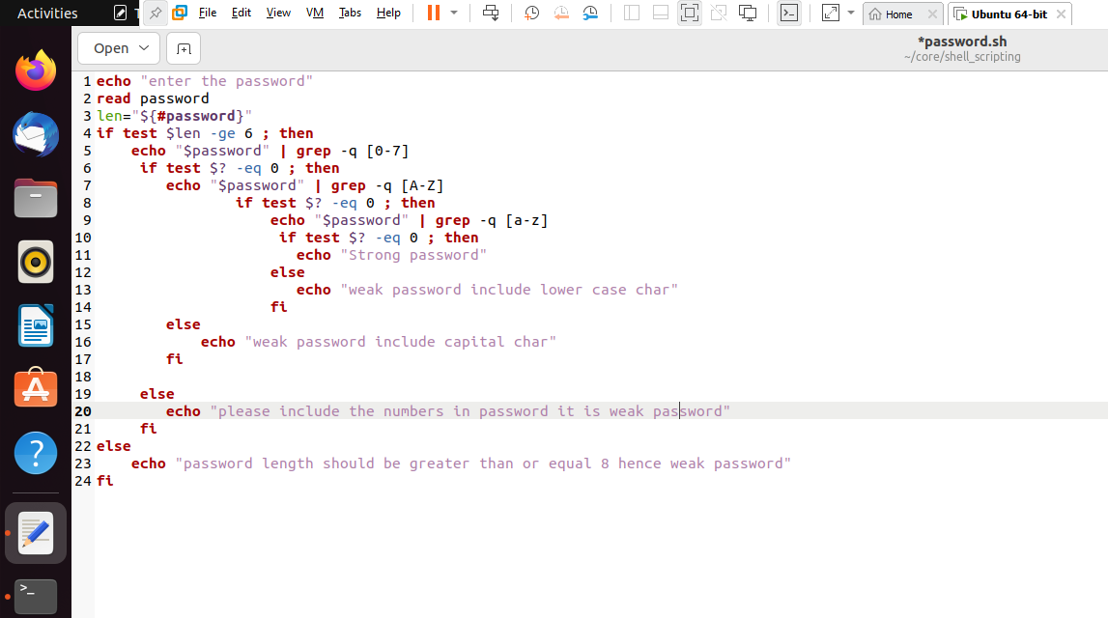

1. Write a shell script to accept two integer values for two variables Perform following actions -  
   Create the following functions for the same -

|  |  |
| --- | --- |
| Operation | Function |
| Addition | add(a,b) |
| Subtraction | subtract(a,b) |
| Division | divide(a,b) |
| Multiplication | multiply(a,b) |

a. Addition   
b. Multiplication   
c. Division  
d. Subtraction   
e. If the input is invalid it should return the input is invalid with a comment.

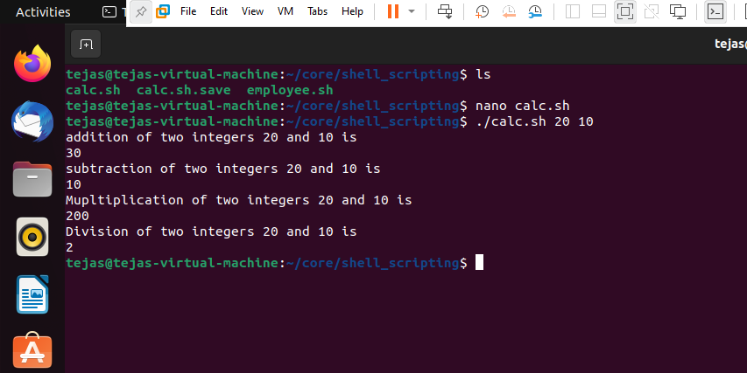

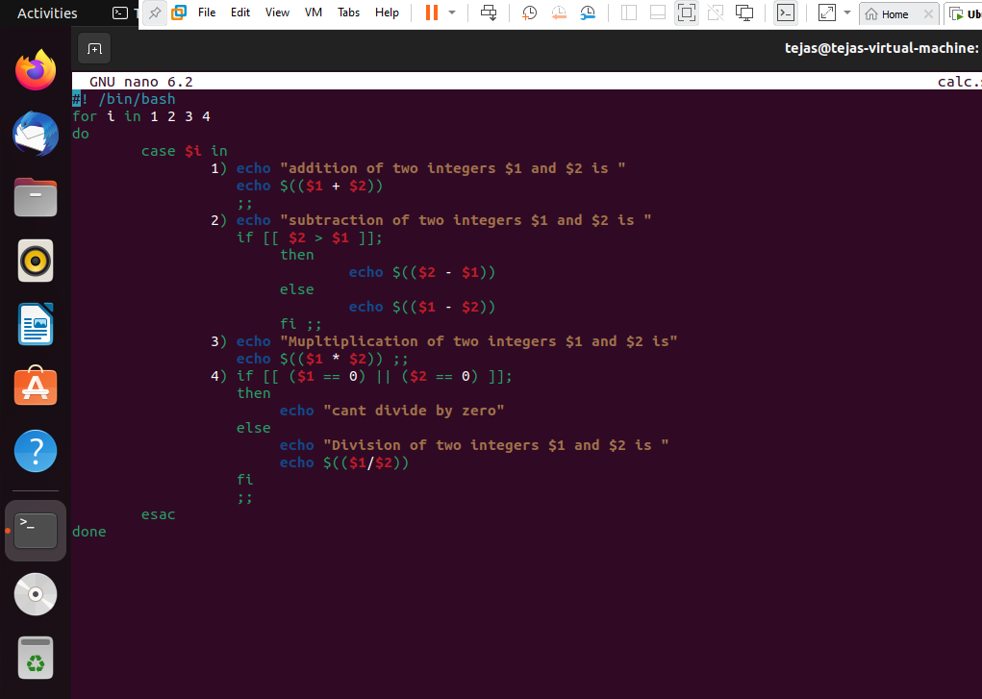

1. Write a shell script that takes a directory as an input and counts the total number of different types of files and directories present in the input directory  
   example -

input_dir/

-- dir1/

-- -- file1.txt

-- -- file1.js

-- -- file2.md

-- -- dir2/

-- -- -- -- file2.txt

-- -- -- -- file2.ts

-- file.md

-- file.sh  
expected Output -

Output

txt: 2

js: 1

md: 2

ts: 1

sh: 1

directories: 2

9.In log file which looks like this:

[status code] IP /endpoint timestamp_utc response_time_s message  
 - give avg response times of all /abc calls  
 - give all endpoints with more than 5 4xx errors  
- give Ip with most API hits

[200] 172.3.4.2 /abc xyz 0.1 OK  
[200] 172.3.43.5 /efg xyz 0.1 OK  
[200] 172.123.4.6 /qwe xyz 0.1 OK  
[200] 172.3.4.24 /abc xyz 0.2 OK  
[400] 172.3.44.2 /abc xyz 0.3 OK  
[400] 172.3.123.9 /qwc xyz 0.3 OK  
[404] 172.33.4.1 /trc xyz 0.3 OK

example - <shell script file> <file name> /<endpoint>

./log_analysis.sh <filename> /abc -> 0.2